**2.Hello World RESTful Web Service**:

**HelloController.java:**

package com.cognizant.springlearn.controller;

import org.slf4j.Logger;

import org.slf4j.LoggerFactory;

import org.springframework.web.bind.annotation.GetMapping;

import org.springframework.web.bind.annotation.RestController;

@RestController

public class HelloController {

@GetMapping("/hello")

public String sayHello() {

return "Hello World!!";

}}

**SpringLearnApplication.java:**

package com.cognizant.springlearn;

import org.slf4j.Logger;

import org.slf4j.LoggerFactory;

import org.springframework.boot.SpringApplication;

import org.springframework.boot.autoconfigure.SpringBootApplication;

@SpringBootApplication

public class SpringLearnApplication {

private static final Logger LOGGER = LoggerFactory.getLogger(SpringLearnApplication.class);

public static void main(String[] args) {

LOGGER.info("START");

SpringApplication.run(SpringLearnApplication.class, args);

LOGGER.info("END");

}}

**application.properties:**

spring.application.name=spring-learn

logging.level.root=DEBUG

server.port=8083

logging.level.com.cognizant=DEBUG

spring.devtools.restart.enabled=false

logging.level.org.springframework.boot.autoconfigure=ERROR

logging.level.root=INFO

logging.level.org.springframework.boot.autoconfigure=ERROR

logging.level.org.springframework.boot.devtools=ERROR

spring.devtools.restart.enabled=false

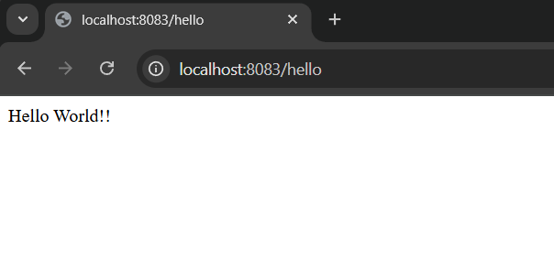

**3.REST - Country Web Service** :

Country.java:

package com.cognizant.springlearn;

import org.slf4j.LoggerFactory;

public class Country {

private String code;

private String name;

public Country() {}

public Country(String code, String name) {

this.code = code;

this.name = name;

}

public String getCode() {

return code;

}

public void setCode(String code) {

this.code = code;

}

public String getName() {

return name;

}

public void setName(String name) {

this.name = name;

}}

**CountryController.java:**

package com.cognizant.springlearn.controller;

import com.cognizant.springlearn.Country;

import org.springframework.context.ApplicationContext;

import org.springframework.context.support.ClassPathXmlApplicationContext;

import org.springframework.web.bind.annotation.RequestMapping;

import org.springframework.web.bind.annotation.RestController;

*@RestController*

public class CountryController {

*@RequestMapping*("/country")

public Country getCountryIndia() {

ApplicationContext context = new ClassPathXmlApplicationContext("country.xml");

Country country = (Country) context.getBean("in");

return country;

}}

**Country.xml:**

<?xml version="1.0" encoding="UTF-8"?>

<beans xmlns="http://www.springframework.org/schema/beans"

xmlns:xsi="http://www.w3.org/2001/XMLSchema-instance"

xsi:schemaLocation="

http://www.springframework.org/schema/beans

https://www.springframework.org/schema/beans/spring-beans.xsd">

<bean id="in" class="com.cognizant.springlearn.Country">

<property name="code" value="IN" />

<property name="name" value="India" />

</bean>

</beans>

**application.properties:**

spring.application.name=spring-learn

logging.level.root=DEBUG

server.port=8085

**SpringLearnApplication.java:**

package com.cognizant.springlearn;

import org.slf4j.Logger;

import org.slf4j.LoggerFactory;

import org.springframework.boot.SpringApplication;

import org.springframework.boot.autoconfigure.SpringBootApplication;

@SpringBootApplication

public class SpringLearnApplication {

private static final Logger LOGGER = LoggerFactory.getLogger(SpringLearnApplication.class);

public static void main(String[] args) {

LOGGER.info("START");

SpringApplication.run(SpringLearnApplication.class, args);

LOGGER.info("END");

}

}

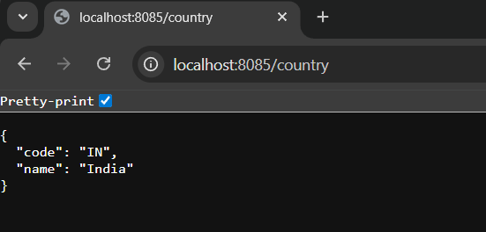

**5.REST Get Country Based on Country Code:**

**Country.java:**

package com.cognizant.springlearn;

public class Country {

private String code;

private String name;

public Country() {}

public Country(String code, String name) {

this.code = code;

this.name = name;

}

public String getCode() {

return code;

}

public void setCode(String code) {

this.code = code;

}

public String getName() {

return name;

}

public void setName(String name) {

this.name = name;

}

}

CountryController.java:

package com.cognizant.springlearn.controller;

import com.cognizant.springlearn.Country;

import com.cognizant.springlearn.service.CountryService;

import org.slf4j.Logger;

import org.slf4j.LoggerFactory;

import org.springframework.beans.factory.annotation.Autowired;

import org.springframework.web.bind.annotation.*;

*@RestController*

public class CountryController {

*@Autowired*

private CountryService countryService;

private static final Logger ***LOGGER*** = LoggerFactory.*getLogger*(CountryController.class);

*@GetMapping*("/countries/{code}")

public Country getCountry(*@PathVariable* String code) throws Exception {

*LOGGER*.info("START getCountry()");

Country country = countryService.getCountry(code);

*LOGGER*.info("END getCountry()");

return country;

}

}

**CountryService.java:**

package com.cognizant.springlearn.service;

import com.cognizant.springlearn.Country;

import org.springframework.beans.factory.annotation.Autowired;

import org.springframework.context.ApplicationContext;

import org.springframework.stereotype.Service;

import java.util.List;

*@Service*

public class CountryService {

*@Autowired*

private ApplicationContext context;

public Country getCountry(String code) throws Exception {

List<Country> countryList = (List<Country>) context.getBean("countryList");

return countryList.stream()

.filter(c -> c.getCode().equalsIgnoreCase(code))

.findFirst()

.orElseThrow(() -> new Exception("Country Not Found"));

}}

**SpringLearnApplication.java:**

package com.cognizant.springlearn;

import org.slf4j.Logger;

import org.slf4j.LoggerFactory;

import org.springframework.boot.SpringApplication;

import org.springframework.boot.autoconfigure.SpringBootApplication;

import org.springframework.context.annotation.ImportResource;

*@SpringBootApplication*

*@ImportResource*("classpath:country.xml")

public class SpringLearnApplication {

private static final Logger *LOGGER* = LoggerFactory.*getLogger*(SpringLearnApplication.class);

public static void main(String[] args) {

*LOGGER*.info("START");

SpringApplication.*run*(SpringLearnApplication.class, args);

*LOGGER*.info("END");

}

}

**Country.xml:**

<?xml version="1.0" encoding="UTF-8"?>

<beans xmlns="http://www.springframework.org/schema/beans"

xmlns:xsi="http://www.w3.org/2001/XMLSchema-instance"

xsi:schemaLocation="

http://www.springframework.org/schema/beans

https://www.springframework.org/schema/beans/spring-beans.xsd">

<bean id="countryList" class="java.util.ArrayList">

<constructor-arg>

<list>

<bean class="com.cognizant.springlearn.Country">

<property name="code" value="IN" />

<property name="name" value="India" />

</bean>

<bean class="com.cognizant.springlearn.Country">

<property name="code" value="US" />

<property name="name" value="United States" />

</bean>

<bean class="com.cognizant.springlearn.Country">

<property name="code" value="JP" />

<property name="name" value="Japan" />

</bean>

</list>

</constructor-arg>

</bean>

</beans>

